The Roanoke Valley Wrestling Association will induct five members into the Roanoke Valley Wrestling Hall of Fame on Monday, April 25, 2022.
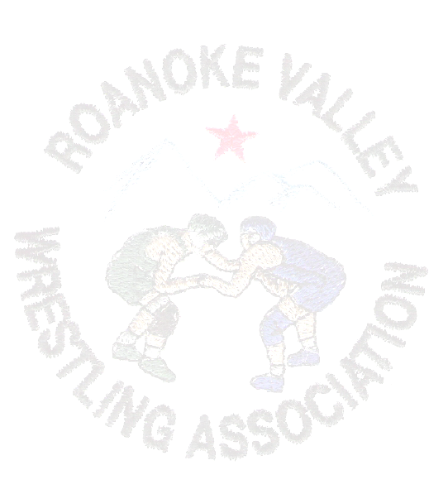
Please join us in honoring the Class of 2020-2021-2022

Don Cox
Wrestled at Virginia School for the Blind
Wrestled at Appalachian State and Virginia Tech
Assistant Coach at Jefferson

Mike Gibson
Wrestled at Glenvar
Coached at William Byrd and Salem
Former Roanoke Valley Wrestling Official

Randall Sell
Wrestled at William Byrd
Wrestled at Messiah College
Coached at Staunton River and Salem and volunteer coach at Lord Botetourt

Talena Williams
One of the first athletic trainers in Roanoke County
Provides athletic medical coverage at the VHSL State Wrestling Tournament
Member of the 2020 US Olympic Medical Staff

Ronnie Wood
Wrestled at William Byrd
Volunteer coach at William Byrd
Recipient of Roanoke Valley Lifetime Achievement Award

A banquet to recognize the Class of 2020-2021-2022 will take place at the Holiday Inn Tanglewood ballroom on Monday, April 25, 2022. Social begins at 6:00 pm followed by a buffet dinner at 6:30 pm. The evening will continue with the presentation of candidates for induction into the Hall of Fame and their acceptance speeches.

The Roanoke Valley Wrestling Association’s annual awards:
Coach of the Year Wrestler of the Year
Sonny Boyd Assistant Coach of the Year
Roy Stanley Outstanding Achievement Award
Ken Shelton Memorial Scholarship Stan Parker Memorial Scholarship
Larry France Memorial Scholarship George Miller Memorial Scholarship

If you reserved your seats for the 2020 banquet, those reservations will carry over to this year. A copy of your reservation form is enclosed and you can make changes to it and return it to Joyce Edmondson at the address on the form.

Come join us in celebrating another group of outstanding individuals, enjoy some great stories, catch up with old friends, and make some new friends.

For more information on this event, please contact:

Joyce Edmondson-(540)354-6688 Jeff Edmondson-(540) 353-1900
Bill Hurd-(540) 819-9658

To reserve your seat at the Roanoke Valley Wrestling Hall of Fame Induction Ceremony and Awards Banquet, please submit the completed form with a check by April 15, 2022 to:

Roanoke Valley Wrestling Association
Attention: Joyce Edmondson
2409 Portland Ave.
Roanoke, VA 24017

Adults (12 & over): ___ @ $35.00 per person
Children (11 & under): ___@ $13.00 per person
Children 4 and under are free ___
Table Reservation: ___@ $350.00 We will fill this table. List names below.
Table Reservation: ___@ $350.00 Please use this to help defray the cost of award winners.
Total amount owed for reservations: $_____________
Please include the names of all guests attending the event:
1.__________________________________ 6.__________________________________
2.__________________________________ 7.__________________________________
3.__________________________________ 8.__________________________________
4.__________________________________ 9.__________________________________
5.__________________________________ 10._________________________________
Sponsorships
Sponsorships are available at a cost of $50.00. All sponsorships will be mentioned during the banquet and in the official event program.

(Please note this does not include the cost of a meal.)

___Yes, I would like to sponsor the event @ $50.00. Indicate below how you want your sponsorship listed.

_______________________________________________________________________

Total cost of sponsorship(s): $______

Total amount owed for reservations and sponsorships: $_____________

Name___________________________________

Address_________________________________

Phone___________________________________


